Chapter 7: Hardware Part

Real Hardware Connections and Implementation
The Smart Migraine Monitoring Device hardware design consists of a single integrated wearable unit composed of multiple interconnected components. This unit is responsible for sensing physiological and environmental parameters, sending the collected data to the database, and providing alert feedback to the user in real time.
The hardware section includes sensors dedicated to monitoring heart rate, temperature, and humidity, all connected to an ESP32 microcontroller that serves as the main processing and communication unit. The design is powered by a rechargeable lithium-ion battery, include a charging module as well and voltage regulation circuitry that ensures efficient operation. The wireless communication is achieved through the ESP32’s built-in Wi-Fi capability, enabling data transmission to a remote server.
To add more, an alert mechanism is integrated into the hardware design to notify the user quietly when migraine-related alerts are triggered. Finally, all components are combined into a compact wearable design, allowing continuous monitoring while maintaining user comfort, portability, and reliability.

Environmental Monitoring (HTU21D)
To detect environmental triggers associated with migraine onset, we selected the HTU21D Temperature and Humidity sensor. This sensor provides calibrated, linearized signals in digital format, ensuring precise measurement of ambient conditions that may influence the user's physiological state.
Key Specifications
- Interface: I2C (Address: 0x40)
- Supply Voltage: 3.3V (Compatible with ESP32 logic levels)
- Measuring Range: 0–100% RH and -40 to +125°C
- Accuracy: ±2% RH and ±0.3°C
HTU21D with ESP32:
The sensor is connected to the ESP32 via the I2C bus using pins GPIO 21 (SDA) and GPIO 22 (SCL). Since the HTU21D operates on the same communication bus as the heart rate sensor, it was critical to ensure no address conflicts occurred. The HTU21D occupies address 0x40, allowing it to function in parallel with other peripherals without interference.

Physiological Monitoring (MAX30102)
The MAX30102 is an integrated pulse oximetry and heart-rate monitor module. It was chosen to provide real-time physiological data (BPM), which serves as a primary indicator of stress or physical exertion—key factors in the project's migraine prediction algorithm.
The sensor operates on the principle of Reflective Photoplethysmography. It integrates two LEDs (Red and Infrared) and a photodetector on the same side of the module.
Key Specifications
- Interface: I2C (Address: 0x57)
- Ultra-Low Power: Can be shut down via software (standby mode) to save battery when not in use.
- Sample Rate: Configurable (set to high-speed sampling in firmware to capture rapid pulse changes).
MAX30102 with ESP32:
Like the environmental sensor, the MAX30102 connects to GPIO 21 (SDA) and GPIO 22 (SCL).
- Power Stability: The module is extremely sensitive to voltage fluctuations. A solid 3.3V connection was mandatory to prevent signal noise, which can result in "NaN" (Not a Number) errors or false readings (e.g., 39 BPM).
- Pull-Up Resistors: The module relies on the ESP32's internal pull-up resistors on the I2C lines to maintain signal integrity during high-speed data transmission.

- Voltage Regulator
The device is powered by a single-cell lithium-ion battery with a nominal voltage of 3.7 V and 1100mAh, which can operate between approximately 3.2 V (discharged) and 4.2 V (fully charged). Since the ESP32 and sensors operate at 3.3 V, a low-dropout voltage regulator (HT7333) which provides a fixed output voltage of 3.3V was selected to ensure that these components are fed the perfect voltage value. These sensitive components are:
- ESP32 microcontroller
- MAX30105 heart rate sensor
- HTU21D temperature and humidity sensor

- Current Consumption Estimation
In order to check that the HT7333 regulator can provide sufficient current, the approximate current floating throughout the circuit was estimated:
- ESP32 (Wi-Fi active): ≈ 180–220 mA (peak)
- MAX30102 sensor: ≈ 20 mA
- HTU21D sensor: ≈ 1 mA
- Other components (logic, leakage): ≈ 10 mA
The total estimated maximum current is:
$$Itotal​ ≈ 220+20+1+10 = 251 mA$$
The HT7333 regulator supports up to ≈ 250 mA, which is enough for normal operation when supported by bulk capacitors to handle short Wi-Fi current collapses.

- Battery Level Measurement Calculation (Voltage Divider)
The system is powered by a Lithium-Polymer (LiPo) battery with a voltage range of 3.2V (discharged) to ~4.2V (fully charged). However, the ESP32’s Analog-to-Digital Converter (ADC) pins operate within a maximum range of 0V to 3.3V. Connecting the battery directly to an input pin would exceed the microcontroller’s voltage tolerance, potentially damaging the GPIO pin and resulting in inaccurate saturated readings.
To solve this, we implemented a voltage divider circuit to step down the battery voltage to a safe value and then connect to the ESP32 ADC.
Circuit design:
The voltage divider consists of two resistors, R1 and R2, connected in series between the battery’s positive terminal ($V_{bat}$) and Ground (GND). The output voltage ($V_{out}$) is measured at the node between the two resistors.
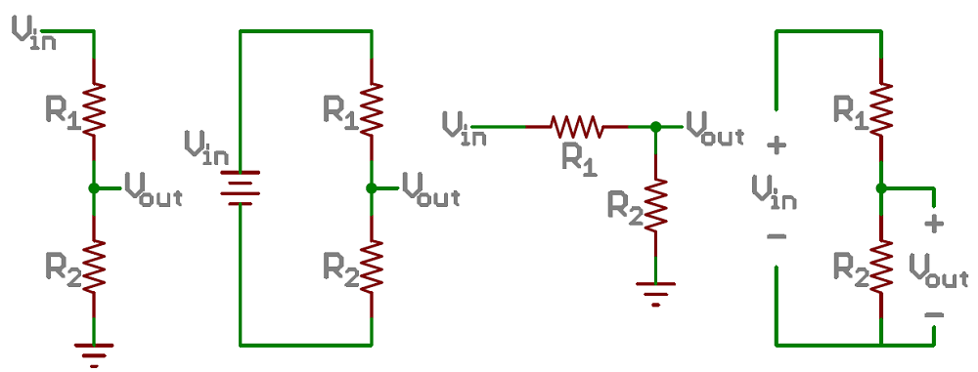
Figure showing voltage divider concept.
Source: https://learn.sparkfun.com/tutorials/voltage-dividers

Component Selection:
- Resistors: We selected two 10 kΩ resistors (R1= 10kΩ, R2 = 10kΩ).
- Voltage Divider Ratio: Using the standard voltage divider formula:
$$V_{out}=V_{bat}×\frac{R_{2}}{R_{1}+R_{2}}$$
Substituting our values:

$$V_{out}=V_{bat}×\frac{10k}{20k}=\frac{V_{bat}}{2}$$

This ratio of 2.0 ensures that even at the maximum battery charge (4.2V), the pin receives only 2.1V, which is safely within the ESP32's linear ADC detection range.
Voltage Divider with ESP32:
The divider output is connected to GPIO 35. This pin was specifically chosen because it belongs to ADC1. The ESP32's ADC2 channels cannot be used while Wi-Fi is active; therefore, using an ADC1 pin ensures reliable readings during data transmission.
The divider output is connected to GPIO 35. This pin was specifically chosen because it belongs to ADC1. The ESP32's ADC2 channels cannot be used while Wi-Fi is active; therefore, using an ADC1 pin ensures reliable readings during data transmission.
Calibration:
During testing, we observed a discrepancy between the theoretical voltage calculation and the actual multimeter readings (e.g., the ADC indicated 45% capacity when the battery was fully charged). This error was attributed to:
- Resistor Tolerance: Real-world variance in the 10kΩ resistors.
- ADC Non-Linearity: The ESP32's internal reference voltage and attenuation characteristics.
To correct this, we implemented a software calibration factor. By comparing the ADC reading against a precise voltmeter reading of 4.05V, we derived a calibration multiplier (approximately 1.11) and adjusted the percentage mapping logic to define 4.05V as 100% and 3.2V as 0%.

- Haptic Feedback Driver (MOSFET Control)
To provide immediate physical feedback to the user upon the detection of a high migraine risk, a vibration motor was integrated into the wearable device. Since the vibration motor requires a drive current (typically 70–100mA) that exceeds the maximum output capability of the ESP32’s GPIO pins (max 12mA–40mA), a dedicated switching circuit was required to amplify the control signal.
Circuit Topology: Switching Control
The motor control circuit is implemented using the switching element (MOSFET) that is placed between the load (motor) and the ground.
- ON State: When the ESP32 sends a HIGH signal (3.3V) to the MOSFET Gate, the channel between the Drain and Source opens, completing the circuit to Ground and allowing current to flow from the battery through the motor.
- OFF State: When the Gate signal is LOW (0V), the channel closes, cutting off the current path.
2N7000 N-Channel MOSFET with ESP32
We selected the 2N7000 N-Channel MOSFET for this application.
- Logic Level Compatibility: The 2N7000 has a low Gate Threshold Voltage (typically 0.8V–3.0V), ensuring it can be fully saturated (turned completely ON) by the ESP32’s GPIO 18 pin without requiring an additional driver stage.
- Current Handling: It can handle continuous drain currents up to 200mA, which provides a safe margin for the vibration motor's load.

Power Supply & Charging Management
The device is powered by a Lithium-Polymer (LiPo) battery. A TP4056 charging module was used to safely manage the charging cycle, protecting the battery from over-voltage and over-discharge conditions critical for lithium-based chemistry.
Battery Specifications
- Type: Lithium-Polymer (LiPo)
- Nominal Voltage: 3.7 V
- Capacity: 1100 mAh
- Max Charging Voltage: 4.2 V
Charging Module (TP4056)
The battery is managed by a TP4056 module with integrated protection, automating the CC/CV (Constant Current / Constant Voltage) charging profile.
- Charging Current: Programmed to ~1A.
- Protection: Cuts off power if voltage exceeds 4.2V or drops below ~2.5V, preventing permanent cell damage.
Battery Life Estimation
Based on the system's power usage analysis, the maximum estimated current consumption during active Wi-Fi transmission is approximately 250 mA.
Using this conservative (worst-case) load, the estimated continuous runtime is:
$$Battery Life = Battery Capacity (mAh)/ Load Current (mA)$$
$$Battery Life = \frac{1100 mAh}{250 mAh}=4.4 hours$$

While the device may achieve longer runtimes in standby modes (where current drops significantly below 250 mA), this calculation guarantees at least 4.4 hours of continuous operation under maximum load conditions.

